Testing Chamber

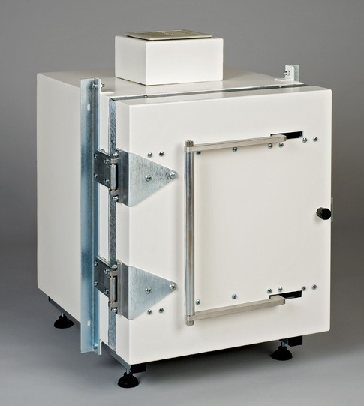
DATA SHEET

Features
- Fast, reliable EMI/RFI testing and verification, while providing 100% effective shielding of 100dB@2.4GHz and 90dB@5.5GHz attenuation as required by EN50147-1 Euro-norm IEE299

- High performance construction of galvanized SAE1020 steel and copper EMC shielding with ROHs compliant welding and RAL 9010 STD coating.

- User Friendly Operation with Front Loading, Swing Away Double Electric Contact door (DEC) with internal parallel, toggle, latch locking action.

- Shielding tested under lab conditions with signal generator by spectrum analyser and conforming antenna. Manufacturer’s C.O.T. and test results included.

- Table top model with 19” mounted in-line rack. Compact, small footprint & portable with immaculate body finish.

- Custom-made product adaptable to any application.

Optional Accessories
- Anechoic absorber lining for the interior surface
- Data adapter kit with penetration panel
- Filtered D Type filtered RJ45, filtered USB, SMA etc connectors.
- Power and signal line filters
- Observation window
- Internal illumination
- Fiberplex waveguide filter for fiber optics
- Grounding Point
- Honey-comb air vents and exhaust fan
- Additional in-port/out-port systems
- Extra custom-made requirements

Dimensions
Table Top Model A: 500mm X 500mm X 500mm Model B (medium size): 900mm X 900mm X 1200mm
Upright Model: 1800mm X 1100mm X 900mm

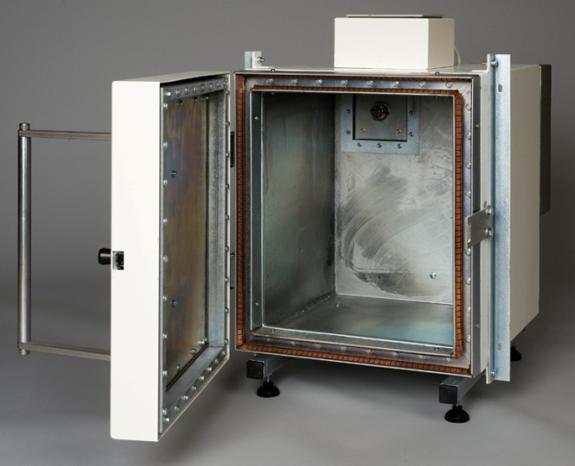
Applications
It is perfect for Wi-Fi, Bluetooth, RFID, 3G & WLAN testing, GPS and Wimax, and may also be used for cell-site to cell-site testing, burst electronics applications, RF resistor testing, two-way radio testing, and susceptibility testing.

This product is designed to meet a variety of demanding testing, QC/QA, and repair requirements calling for shielding performance through to 100dB. It may be used in any environment where the equipment under test needs high performance RF shielding, while isolating it from the operator.

